Evaluating the natural capital value of the New Forest National Park and surrounds for health and wellbeing
Dr James Alden, ST6 Paediatric Registar and Public Health Fellow, MBBS iBSc MRCPCH
Acknowledgements
We are grateful for the time and insight of the ONS team who published the Health Benefits of Recreation, Natural Capital report and ensured our understanding and relevance of their data to the local area of the New Forest and surrounds.
Introduction
Natural England estimates that £2.1 billion per year could be saved in health costs if everyone in England had good access to greenspace. This is underpinned by a growing evidence base that natural environments bring multiple health benefits to the population. However, it is a challenge to assign monetary value to this, given that the mechanisms by which they confer this benefit are not fully understood, and valuation methods rely on certain assumptions being made. Despite this, a recently published report by the Office for National Statistics (ONS) provides a useful insight into national level impacts of ‘natural capital’ on avoided healthcare costs.
An exploration of how the outcomes of the ONS report might be applied to a local area, such as the New Forest National Park and its surroundings, may help to enhance understanding of the value of its natural capital health benefits. This scoping piece seeks to do that, taking appropriate consideration of local factors such as demography, accessibility and health and income inequality (all of which are related to each other), as well as acknowledging the limitations of the methodology.
This review makes a preliminary exploration and valuation of how the New Forest currently improves health outcomes and wellbeing in generic terms, following recent publications that seek to value this relationship. Suggestions of interventions/projects which seek to enhance this relationship are then made, to show the potential value of new investment in natural capital for health in the New Forest and surrounding area.

What is natural capital and how does it relate to the New Forest?
Natural capital is the value of the natural green and blue spaces around us and relates to the benefits it can or does provide to the public. It is possible for this to be given a monetary value, but it is challenging to accurately account for all the benefits enjoyed in purely financial terms. It requires a consideration of existing assets, which require maintenance capital (read ‘money’), and the potential to invest in new greenspace/infrastructure and seeking to understand the broader value of a new investment.
Natural capital is divided into three broad ‘services’:
- Provisioning services – resource utilisation, such as crops, water, fuel (both renewable and non-renewable), timber, minerals, fish
- Regulating services – maintaining the quality of the environment such as carbon sequestration, air pollutant removal, urban cooling, and noise mitigation
- Cultural services – includes tourism and recreation, house prices
An increasingly recognised aspect of valuing natural capital is including the benefits it confers to the wider population’s health and wellbeing. Attempts to assign a value to this have been made. To an extent health and wellbeing may straddle all three, and therefore its economic contribution to natural capital is likely to be cross-cutting. A government report on improving access to greenspace, published in 2020 states, ‘greenspace can improve social contacts and give people a sense of familiarity and belonging – cleaner, greener communities are places where people wish to live and work’.

What is health and wellbeing and what has it got to do with natural capital?
Natural England has written of four key benefits from well-planned green infrastructure; health and wellbeing, thriving nature and biodiversity gains, making places more resilient to climate change, and adding value and supporting prosperous communities. Our natural ecosystems provide necessities for life, such as food and water, but they also provide meaningful social and cultural places that people interact with and enjoy.
This has been shown to have a benefit for people’s health and wellbeing. Studies have shown that increased access to nature or a green space improves physical health, reducing the risk of dying from all causes. In addition to this, access to nature is linked with improvements in self-reported or carer-reported wellbeing of children, young people, and adults. A study from 2016 showed that those who spent at least 120 minutes in nature per week had higher levels of self-reported health and subjective wellbeing in comparison to those reporting no nature exposure.
Longer times spent in nature are associated with a greater benefit, but the rate of increase does diminish to a natural ceiling at about 300 minutes of time spent in nature, implying the benefit of regularity rather than ‘saturation’. Health and wellbeing is a key part of the equation when considering the beneficiary value of natural capital.
‘Health in all policies’, which the New Forest Public Health Fellowship role exemplifies, is increasingly recognised as an important factor in the wider push towards preventative health and wellbeing. The dynamics of health and social care policy are also shifting in this direction, both centrally and locally. Green infrastructure and natural capital have an important role to play in the preventative health approach but also as a targeted treatment option for those population groups who are underserved.
A seminal paper by Mitchell and Popham, published in 2008, demonstrated that living in greener environments results in reduced all-cause mortality. More importantly, it was shown to mitigate the health effects of inequality. The difference in risk of dying between the most and least deprived population quartiles is much smaller in the greenest neighbourhoods (IRR 1.4) and much greater in the least green (IRR 1.9) as is demonstrated in Figure 1. Crucially, this study suggests that living in a greener neighbourhood is likely to be an independent factor in improving health outcomes, because even when adjusted for wealth, differences in risk of dying still exist.
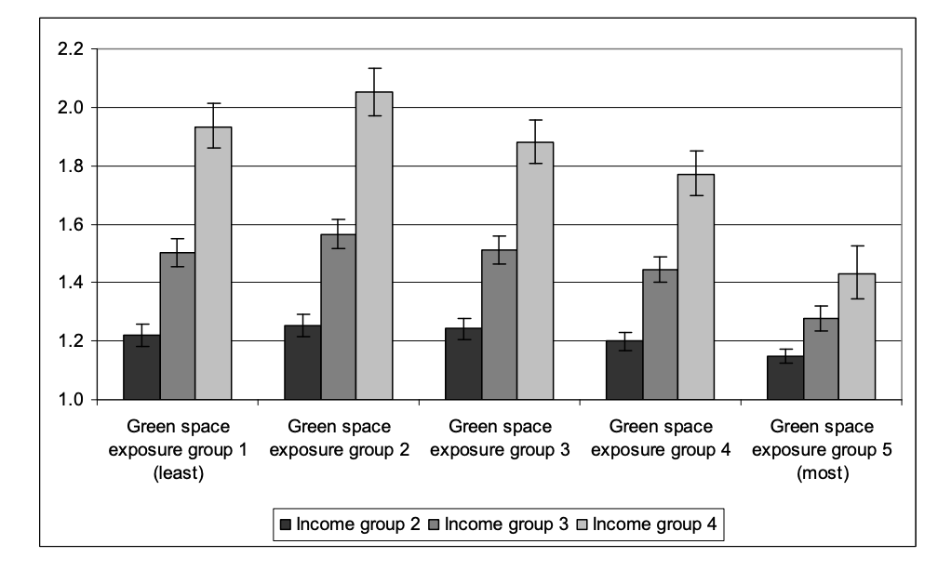
Figure 1: Incidence rate ratios (with 95% confidence intervals) for all-cause mortality in income deprivation quartiles 2-4, relative to income deprivation quartile 1 (least deprived), stratified by green space exposure group

This is a useful example of how wider determinants affect health outcomes at a population level. Inequality within these measures, such as the built and natural environment, income, employment, access to services, housing quality, and pollution have been shown to drive health inequality. With respect to the built and natural environment, air quality encapsulates the challenges inherent in this relationship. Particulate matter (PM2.5) generated by vehicles and industrial processes, is estimated to cost the NHS £1.69 billion in England between 2017-2025. Southampton has particularly high levels of PM2.5. Further, the estimated annual value of natural capital in removing air pollutants is £1.38billion in terms of avoided healthcare costs. A crude estimate of the New Forest’s contribution can be made based upon its area (558sq km); £3.04 million, although this is likely to underestimate the quality of the natural capital and its ability to mitigate the effects of pollution.
The emerging cost of living crisis is an additional concern, given that inflationary environments (particularly of non-discretionary items such as household bills), hit the poorest, hardest. The New Forest, while not significantly deprived overall, has multiple pockets of deprivation and the two local urban centres, Southampton and Bournemouth, have areas that are among the most deprived in the country (bottom 10% as per IMD 2019). In a report by Citizens Advice, 4% of residents in the New Forest District accessed a food bank in 2020, a number which is likely to have increased in the context of substantial inflation. The rural nature of some of the New Forest populations can exacerbate the problem; the report noted that rural areas were especially sensitive to higher costs, and small pockets of deprivation may not be adequately represented at local population level, particularly in more sparsely populated areas. It further commented that these rural populations face the double burden of higher costs for goods combined with the inability to access affordable alternatives, secondary to transport limitations, which in turn carry cost implications.
The Covid-19 pandemic is likely to have exacerbated some of the challenges that many in the most deprived populations have faced. Longer term consequences of the pandemic are yet to be fully understood, but all are aware of the unprecedented pressure on the NHS and the fallout of some people’s health needs not being fully met during the last three years. It in turn highlights the need to fully value the resource that is readily available in the New Forest and the impact it can have on health and wellbeing – natural space.
We also know that physical activity confers significant physical and mental health benefits, but studies have also shown some evidence of additional mental health and wellbeing benefits of being active outdoors. In the context of the pandemic, exercise trends changed with many unable to attend a gym or other indoor exercise environment. This meant many went outside instead; this trend is now reversing and may represent a missed opportunity to reinforce the likely additional benefit of exercising outdoors. The health benefits derived from physical activity are non-linear in nature; the biggest benefit occurs when a person who is ‘inactive’, becomes ‘active’. Utilising this knowledge in the context of green infrastructure design infers that greenspace should enable physical activity, wherever possible.

The New Forest and surrounding area – a rich source of natural capital

Figure 2: A population pyramid which demonstrates the difference in age distribution of the New Forest in comparison to the population of England and Wales, from 2021 census data

The New Forest District, a local authority which encompasses the borders of the National Park and some additional land, has a population of 175,800 according to the 2021 census. This equates to a 0.4% reduction from previous census data in 2011, which put the population at 176,462. In addition, the demographic make-up of the New Forest is different to the broader population of the country. It has an older population and a greater percentage of those from a white ethnic background.

The graph above demonstrates the age distribution of the New Forest (in blue) versus that of the whole of England and Wales.

Beyond the New Forest district, there are two large urban population centres; Southampton, with a demographically diverse and young population totalling 249,000, and Bournemouth, (Christchurch and Poole) with a population of 400,300. Both areas are on the coast and ‘blue infrastructure’ is also a very important consideration as another aspect of ‘natural capital’. In addition, both areas have pockets of significant deprivation and demographic variations which may impact how people interact with the natural environment. We know that older and more deprived people are less active, for example, and in turn less likely to be active outdoors. Southampton and the New Forest district have a greater proportion of inactive people than the national average.
The New Forest National Park itself was formed in 2005 and covers an area of approximately 558 sq km. It is a rich source of natural capital with great value, and both local and national significance. Its land management practices, such as commoning, and its rich biodiversity, demonstrate its cultural value and the fact it is one of the most visited national parks speaks to the economic benefits it provides for the local population. A recent report undertaken by the Forest Farmer’s group found that most aspects of the local natural capital were in reasonable health, but there were concerns around commoners’ housing availability and biodiversity of rare species. It provided a qualitative assessment of the state of various factors that contribute to natural capital including both human and natural resources. It summarised the special qualities of the park as follows:

- Outstanding natural beauty
- The extraordinary diversity of plants and animals
- A unique historic, cultural and archaeological heritage
- An historic commoning system
- Tranquillity
- Opportunities for quiet recreation, learning and discovery
- The iconic New Forest pony
- Strong and distinctive local communities
- A healthy environment.

This list provides a distinctly local flavour of the perceived benefits of natural capital in the New Forest. However, while animal health was included in this report as a consideration in the value and status of natural capital, human health and wellbeing was not. At a national level, health is increasingly recognised as an important aspect of the broader valuation of natural capital and as a justification for investment in ‘green infrastructure’.
As a national park, the New Forest has the following purposes:
- To conserve and enhance the natural beauty, wildlife, and cultural heritage of the area
- To promote opportunities for the understanding and enjoyment of the special qualities of the National Park by the public.
While these statutory aims are typically well aligned, there is occasion where they come into conflict. The Sandford Principle prioritises conservation above public enjoyment in this case (i.e. the first principle takes precedence). This is an important consideration in the development and application of any health and wellbeing strategy for greenspace.
The National Park seeks to foster economic and social wellbeing within local communities, and health is a key part of the wellbeing equation. Further to this, Natural England states; ‘The provision, modification or use of green infrastructure to promote health and wellbeing is most likely to be successful if there is a good understanding of the local social, cultural and economic context, where the health needs of target populations are understood, and where linkages are made with, and buy-in gained from wider networks of social and health services’. New Forest organisations are in a fantastic position to mitigate the tension between the two statutory duties. As indicated by Natural England, a key part of that equation is ensuring local buy-in of natural capital’s immense value. As we look forwards, improving our relationship with the natural environment is essential to understanding and improving our population health.

ONS report
A report was published by the Office for National Statistics in May 2022 which sought to value the benefits of exposure to natural capital in terms of avoided healthcare costs. It used data from the MENE (Monitor of engagement with the Natural environment) questionnaire, which is facilitated by Natural England, as its primary source. This does not include children under the age of 16. The ONS explored the estimated value of health benefits through two different approaches, both of which are important in the context of how the New Forest is used by the public:
- Outdoor exercise approach – 30 minutes of moderate to vigorous physical activity, five times a week, and counting how many of them occurred in nature
- Exposure to nature approach – spending at least 120 minutes or more in nature per week.
The benefits were estimated in terms of quality adjusted life years, known as ‘QALYs’, based upon pre-existing research estimates of the healthcare cost benefit of the two metrics given above. A QALY is a measure of the state of health of a person, adjusted to reflect their quality of life annually; one QALY is equal to one year of life in perfect health. The cost to the NHS (in 2008) of a QALY gain of 1, was £12,936.00 in 2008, a figure which can then be inflation-adjusted for the proceeding years. To provide an illustrative example of the utility of QALYs; if a hip replacement improved your quality of life such that your QALY score went from 0.7 to 0.8 (so the difference is 0.1) over a period of 20 years, your total QALY gain would be 2 (0.1*20). You could then consider the cost of the intervention (hip replacement operation and follow up approx. £20,000) and estimate that the ‘cost per QALY’ of this intervention would be £10,000 which is good value (n.b. the true cost per QALY value of hip replacement surgery is approx. £7,500, compared with no surgery).
While monetary valuation presents its own limitations and is not the only way to see value in health and wellbeing, it is a universally understood ‘language’ and allows people from a non-health background to understand the importance of natural space in a way that they may not have previously considered.
The total annual value for outdoor exercise was £8.4 billion and the number of people who ‘qualified’ in the UK was 11.5 million. The per person (capita) benefit was calculated at £141.83 when applied to the whole population, but if applying the value exclusively to the ‘qualifiers’, (i.e. those that were active for the necessary time), this increases to £716.99. For nature exposure, the total annual value was £6.2 billion and the number who qualified was 19 million in 2020; a notable reduction from 21 million in 2019. The per capita benefit was £115.69, and if applied to the qualifiers who fulfilled the inclusion criteria, it was £331.41.
It is intuitive that being active outdoors would confer a larger benefit per person than nature exposure, as we have a broader and more established evidence base for physical activity improving both physical and mental health. It is important to note, however, that these numbers are not mutually exclusive. There are many people who, in exercising outdoors, also fulfil the criteria for spending time in nature. In fact, the ONS report states that ‘on average 90% of those who gained health benefits from outdoor exercise also gained benefits from exposure to nature’. The true benefit is likely to exist in between the two figures and it gives a reasonable estimate range.
Notably, parks and garden spaces, which are one of the categories within the MENE questionnaire, were the single biggest contributing category to the health benefits of natural capital. They are responsible for 39% and 38% of avoided healthcare cost value for the outdoor exercise and nature exposure metrics, respectively. This benefit is due to the intensity of their use and is likely a proxy indicator of the importance of proximity of greenspaces, particularly in densely populated urban areas. Other sources corroborate the value of local greenspace, particularly to underserved populations.
Those in deprived neighbourhoods are less likely to have a private garden but are much more likely to live within walking distance of a public park (34% vs 18% general population), a relative triumph of urban planning. Given that deprivation is associated with urban centres, it is unsurprising that these areas have the lowest access to private gardens. For example, in Central Southampton East, 58% of dwellings do not have a private garden in comparison with Holbury North, Blackfield and Fawley where only 6% are without a garden. This demonstrates the need for a joined-up approach to greenspaces and natural capital, and exemplifies the benefits of multiple types of natural environment. Parks and local greenspaces may also help to mitigate overuse of more vulnerable landscapes such as sites of special scientific interest and protected areas by minimising overuse and it is important that this is considered in policymaking.

Applying this data to the New Forest: Telephone interview report
A recent telephone survey commissioned by the National Park Authority in 2018, allowed for local data to be applied to the ‘nature exposure’ metric used in the ONS report. The purpose of the survey was to obtain data on local population visits to the ecologically rich heaths and woodland areas of the New Forest National Park. The survey sample was obtained randomly, which increased its value (as opposed to a very biased sample of only those who visited the national park, as is more common in these types of surveys).
A 25km band was applied to the area surrounding the New Forest, bracketing six local authorities: Bournemouth, Christchurch and Poole, New Forest District, Southampton, Eastleigh, Fareham, and Gosport. Because these were fully represented, population data from the 2021 census could be used. The partially covered local authorities were not included, as it was impossible to calculate the populations of these areas that truly fell within the 25km inclusion zone.
Based upon simple demographic data, values for avoided healthcare costs can be established more generally for the adult population of the New Forest District and the five other local authorities that fall within the 25km radius as per the telephone survey. These will include the health benefit of all natural capital within the areas, from Bournemouth beaches to Gosport parks, and cannot be ascribed only to the New Forest.
Of note, these population figures are derived from 2021 census data, whereas the ONS report from which the healthcare benefits are calculated are based on predicted national values from 2021, which may result in a small difference in the value. We can calculate the values based upon both categories used within the ONS report; that of exercise outdoors, and that of nature exposure. The total local area value of natural capital for outdoor exercise and nature exposure were £138 million and £112 million respectively. The tables below demonstrate the calculations to establish these values (See Table 1 and 2).
These monetary values provide a useful, but quite general sense of the health and wellbeing benefit of local natural capital and are not specific to the New Forest National Park. We can calculate more detailed, New Forest-specific values for the ‘nature exposure’ method based upon the data collected from the New Forest telephone survey as it is possible to work out who qualified for this benefit. This is not possible with the ‘outdoor exercise’ category as the telephone survey does not capture sufficient data to enable further calculation.
In addition, the survey participants who qualified for the benefit of nature exposure for an average of 120 minutes a week are assigned a value of £331.41 of healthcare avoided costs. To provide perspective, this value is equivalent to the cost of eight General Practitioner appointments per year.
A more specific figure can be applied to the New Forest, using data incorporated from the telephone survey. A sufficient sample size was obtained for each of the aforementioned local authorities such that individual calculations could be made and then compiled to generate a total value of the New Forest in terms of healthcare avoided costs. This cumulative benefit of nature exposure in the New Forest heaths and woodlands was £27 million per annum. This is a substantial figure; equivalent to the starting salary of 1,000 nurses. Predictably, the greatest benefit is to those within the New Forest district, and the least to those in Gosport. Behaviour change was also borne out as expected in that proximity typically resulted in shorter, more frequent trips, and distance resulted in longer, less frequent trips.
One limitation of this dataset is that it was collected in 2018, but the ONS report focuses on the dataset obtained in 2020, during the covid-19 pandemic. It is important to acknowledge the substantial behaviour changes that occurred during this period and that may therefore affect the ONS data, although pre-pandemic behaviour and activity trends seem to be returning. It would be helpful to compare over the coming years to establish the impact that covid-19 might have had over a longer timeframe.

Continues below/…
Table 1: Outdoor exercise annual healthcare avoided cost total monetary benefit
Local authority | New Forest | Bournemouth | Southampton | Eastleigh | Fareham | Gosport
Adult population | 150,600 | 338,900 | 207,000 | 111,900 | 96,700 | 68,100
Per capita benefit outdoor exercise | 141.83 | 141.83 | 141.83 | 141.83 | 141.83 | 141.83
LA health benefit outdoor exercise | £21,359,598.00 | £48,066,187.00 | £29,358,810.00 | £15,870,777.00 | £13,714,961.00 | £9,658,623.00
 |  |  | Total health benefit |  |  | £138,028,956.00
Local authority | New Forest | Bournemouth | Southampton | Eastleigh | Fareham | Gosport
Adult population | 150,600 | 338,900 | 207,000 | 111,900 | 96,700 | 68,100
Per capita benefit nature exposure | £115.69 | £115.69 | £115.69 | £115.69 | £115.69 | £115.69
LA health benefit nature exposure | £17,422,589.73 | £39,206,611.28 | £23,947,384.29 | £12,945,470.06 | £11,187,014.79 | £7,878,342.37
 |  |  | Total health benefit |  |  | £112,587,412.50

Table 2: Nature exposure annual healthcare avoided costs total monetary benefit

c
Figure 3: Healthcare avoided cost benefit of the New Forest heaths and woodlands, broken down by local authority
The telephone study only refers to specific New Forest sites (heaths and woodlands), and therefore represents an underestimate of the benefits of the New Forest to avoided healthcare costs, as it is not a full representation of visitors to the New Forest.
Another limitation of this method is that it uses a ‘qualifier’ as inclusion i.e., if you go the greenspace for an average once a week for 120 minutes, you qualify, and vice versa. This is unlikely to encompass all of the benefits accrued as it simply includes ‘qualifiers’ in the data. It is much more likely that there is a continuum of benefit, i.e., those who visit for less than 120 minutes per week are still likely to experience some health benefit but measuring these smaller gains is more challenging given the existing evidence attaches QALY benefits to visits of at least 120 minutes.
Further to this, the telephone survey reports that those that said they visited the New Forest sites went, on average, 72 times per year. It may be that visitors who attended had a greater health benefit than suggested by the ONS monetary figure but there is no data to support this, and one might expect there to be a law of diminishing returns.
None of the data considers socioeconomic factors, and further exploration of this, which may necessitate further data collection, would likely result in a richer understanding of the benefits of greenspace/natural capital to different socioeconomic groups. Indeed, we know that more deprived populations have greater health benefits from accessing greenspace and it may be the case that these populations therefore have greater benefit from accessing the New Forest.

Discussion and suggestions for maximising intervention benefit
This data demonstrates the value of existing natural capital within the New Forest and the surrounding area from a health and wellbeing perspective. Using monetary figures helps to lend understanding to the concept of health within natural capital and using a universally understood concept - ‘money’ - broadens the audience with which this work can be shared. We know that getting people out in nature provides many health benefits, and that getting them out and physically active is even better (on a per person basis), something which should be considered in natural capital investment and maintenance.
This report exemplifies the health and wellbeing value of the New Forest to the local population, but it also demonstrates that other sources of natural capital are important, particularly local greenspaces. Introducing good quality, accessible, thoughtfully designed greenspace locally, where it is scarce, should therefore be a national priority. An example of how this might be supported by organisations with expertise in natural capital investment, maintenance, and conservation, is the concept of twinning, where a local park or even smaller greenspace could have a corresponding area assigned to it in the national park.
This would also characterise the importance of seeing the potential of natural capital investment to deepen partnerships across local areas while also helping the park to mitigate the intensity of park use (for example by twinning with less popular areas). All greenspaces should be championed by local authorities and the healthcare system for their benefits. Indeed, leveraging local health networks is important to maximise the value of the natural environment from a health perspective, ensuring an individualised approach such that the right person does the right activity.
Social prescribing, where people are connected to practical and emotional community support through link workers, seeks to do this and is an important part of maximising the healthcare value of nature. In addition, the presence of local knowledge spaces, such as digital and in-person signposting services provide a forum for information provision and exchange helping to mitigate barriers to access and empower link workers/social prescribers to access the health and wellbeing offer of the New Forest National Park.
The methodology also provides a potential tool for valuing targeted interventions or new investments in natural capital. The report findings are relevant to all scales of intervention, from a new walking group to investment in a new urban park. In addition, focusing on certain groups is likely to result in greater returns on investment, such as deprived populations, particular communities, and inactive people. Incorporating local knowledge in the form of stakeholder engagement and buy-in, is therefore vital.
Natural England recognise this in their scoping review of Green Infrastructure: ‘involving communities and local stakeholders in discussions on long term management can be very valuable. They often have insights into local needs and issues. They may become involved in management delivery, but this has to be matched by appropriate resources both in terms of funding but also staff support’.
The application of the ONS report to local areas and specific interventions is possible provided local data collection is adequate. Specific information is required to be available or collected prior to an intervention such that if change is seen, it can be fairly attributed. This includes data that can be mapped to the relevant ONS data and the MENE /People and Nature dataset, such as pre-existing nature exposure and outdoor activity in a local area. The telephone survey allowed for an understanding of nature exposure health benefits but did not capture sufficient data to understand activity benefits. Future data capture should ensure that a value estimate of physical activity in the New Forest is possible. These illustrative examples shed insights into how this might be possible:
A cycling route from Totton to Ashurst
Cycling is an important activity within the national park and offers an approximate value of £3,689,802.00 in healthcare avoided costs annually. A small percentage of visitors to the New Forest do it, but if they do, they are likely to be physically active and gain a health benefit from it. Some cycle to the New Forest in order to continue with that activity, but many will arrive by car before cycling within the Forest. ORVAL approximate that of the total estimated trips of 10,743,882 made to the New Forest, 8,158,439 (75.9%) are made by car, while only 2,585,443 (24.1%) are not. Enabling local populations to access the New Forest in other ways is important from an ecological perspective but should also result in health benefits if it resulted in increased nature exposure and outdoor physical activity.
Totton and Eling is a civil parish within the New Forest district which is on the border of the New Forest National Park. It has an approximate population of 22,900 and has some pockets of deprivation. If a cycle path, designed to link Totton and Eling to Ashurst in the New Forest, was shown to improve cycling activity this could be modelled to provide an estimated health and wellbeing value independent of other potential benefits.
For example, if this theoretical cycle path resulted in a 10% increase in cycling engagement across the Totton population, this could be estimated to result in an avoided healthcare cost gain of £408,000. Pre-existing data capture would be important to ensure that other beneficial activities were not simply reflecting a change of activity, i.e. ensuring that already active walkers or runners who already qualify for the benefit, were not just switching activities. The provision of a cycle path would also dovetail effectively with an existing offer within the New Forest.
PEDALL, an inclusive cycling charity, has recently opened a hub in Ashurst from which it will offer guided rides on bikes which cater for various needs. The potential synergies offer the opportunity to maximise value-add and could be leveraged by social prescribers, for example, ensuring the right people are offered the right activity.
Southampton Park
Another example demonstrates how you might apply the model/tool. Southampton has pockets of significant deprivation and is relatively greenspace poor; it recently came 56th out of 68 urban centres in the UK for greenspace presence.
If you were able to create a new well-designed local park in a relatively greenspace poor area in Southampton considering how you might maximise value by targeting underserved elements of the population, you would be able to demonstrate significant value-add in terms of healthcare avoided costs. The map (Figure 4) demonstrates the more deprived areas in Southampton, with the darker blue areas representing greater deprivation.
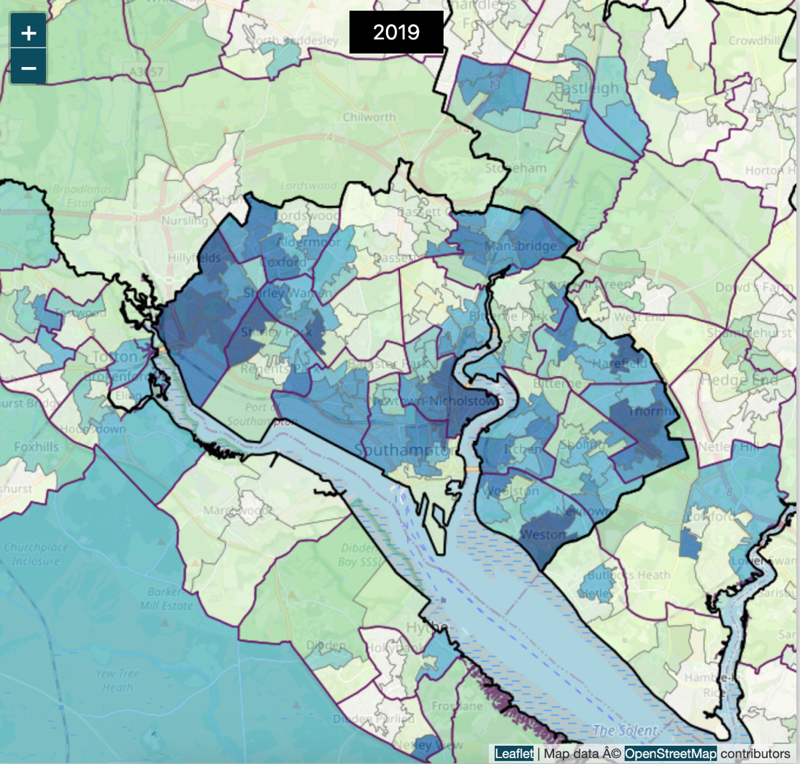
Figure 4: IMD 2019 mapping Southampton; darker blue represents greater deprivation and vice versa
Assuming the park resulted in a 1% increase in qualifiers for nature exposure or in outdoor physical activity (of the total population of Southampton), this would result in healthcare avoided cost benefits of £825,000 and £1.78 million respectively. This is an ambitious increase, and again would require comprehensive data collection prior to the intervention but provides a useful sense of the potential healthcare value calculations for a new investment in natural capital.

Summary
Key messages can be drawn from this exploration of the ONS report and its relevance to the New Forest National Park. Using the telephone survey data, a preliminary estimate of the value of existing natural capital to health and wellbeing of the local population has been outlined. In addition, exemplar interventions suggest how future or new investment may be valued too, and so inform decisionmakers, such as local authorities, local and larger businesses (such as developers), and the NHS either directly or indirectly. Much is still to be explored and understood, but this report helps to provide meaningful data to move the conversation forward around the natural capital value for health and wellbeing.

Bibliography and references
Davies, H., Nayee, N., Health Benefits from Recreation, Natural Capital, UK, Office for National Statistics, 2022; Link https://www.ons.gov.uk/economy/environmentalaccounts/bulletins/healthbenefitsfromrecreationnaturalcapitaluk/2022#toc
Green Infrastructure Framework, Natural England, 2023; Link (https://designatedsites.naturalengland.org.uk/GreenInfrastructure/Principles/HowPrinciples.aspx)
Enabling a Natural Capital Approach Guidance, Department for Environment, Food and Rural Affairs (DEFRA), 2021; Link https://www.gov.uk/government/publications/enabling-a-natural-capital-approach-enca-guidance/enabling-a-natural-capital-approach-guidance#annex-3-economic-valuation-methods
Mitchell, R., Popham, F., Effect of Exposure to Natural Environment on Health Inequalities: An Observational Population Study, The Lancet 372(9650): pp 1655-1660, 2008; Link http://eprints.gla.ac.uk/4767/1/4767.pdf
White, M.P., Alcock, I., Grellier, J. et al, Spending at least 120 minutes a week in nature is associated with good health and wellbeing, Scientific reports, 9:3370, 2016; Link https://www.ncbi.nlm.nih.gov/pmc/articles/PMC6565732/
The NHS Long Term Plan, 2019; Link https://www.longtermplan.nhs.uk/wp-content/uploads/2019/08/nhs-long-term-plan-version-1.2.pdf
Health Profile for England: 2018, Chapter 6: Wider Determinants of Health; 2018; Link https://www.gov.uk/government/publications/health-profile-for-england-2018/chapter-6-wider-determinants-of-health
Davies, H., Dutton, A., UK natural capital accounts: 2021; Link https://www.ons.gov.uk/economy/environmentalaccounts/bulletins/uknaturalcapitalaccounts/2021
Corlett, A., Try, L., The Living Standards Outlook 2022, The Resolution Foundation, 2022; Link https://www.resolutionfoundation.org/publications/the-living-standards-outlook-2022/
English Indices of Deprivation, Ministry of Housing, Communities & Local Government, 2019; Link https://assets.publishing.service.gov.uk/government/uploads/system/uploads/attachment_data/file/835115/IoD2019_Statistical_Release.pdf
Smith, D. et al, The Cost of Living in the New Forest, Multi-agency report, 2022; Link https://newforestcab.org.uk/cost-of-living-in-the-new-forest/
Coon JT et al, Does Participating in Physical Activity in Outdoor Natural Environments Have a Greater Effect on Physical and Mental Wellbeing then Physical Activity Indoors? A systematic review; Environ. Sci. Technol; 45, 5, 1762 – 1772, 2011; Link https://pubs.acs.org/doi/10.1021/es102947t
Active Lives Adult Survey November 2020-2021 Report, Sport England, 2022; Link https://sportengland-production-files.s3.eu-west-2.amazonaws.com/s3fs-public/2022-04/Active%20Lives%20Adult%20Survey%20November%2020-21%20Report.pdf?VersionId=nPU_v3jFjwG8o_xnv62FcKOdEiVmRWCb
Census 2021, Office for National Statistics, 2022; Link https://www.ons.gov.uk/census/maps
Understanding the New Forest’s Natural Capital, Forest Farming Group (New Forest), 2019; Link https://www.newforestnpa.gov.uk/app/uploads/2019/10/00995-NF-Natural-Capital-Report-web.pdf
Annual Review 2021/22, New Forest National Park Authority, 2022; Link https://www.newforestnpa.gov.uk/annual-review/
Inactivity Profiles, PHE fingertips, Office for Health Improvement and Disparities, accessed 2022; Link https://fingertips.phe.org.uk/

A Rapid Scoping Review of Health and Wellbeing Evidence for the Framework of Green Infrastructure Standards (NEER015), Natural England, 2020; Link http://publications.naturalengland.org.uk/publication/4799558023643136
Beale et al., Health Survey for England, 2007; Link https://digital.nhs.uk/data-and-information/publications/statistical/health-survey-for-england/health-survey-for-england-2007-healthy-lifestyles-knowledge-attitudes-and-behaviour
Fordham, R. Skinner, J., Wang, X., The economic benefit of hip replacement: a 5-year follow-up of costs and outcomes, Exeter Primary Outcomes Study, BMJ Open 2:e000752, 2012; Link https://bmjopen.bmj.com/content/2/3/e000752.citation-tools
One in Eight British Households has no Garden, Office for National Statistics, 2020; Link https://www.ons.gov.uk/economy/environmentalaccounts/articles/oneineightbritishhouseholdshasnogarden/2020-05-14

Liley, D., Panter, C., Recreation use of the New Forest SAC/SPA Ramsar: Results of a telephone survey with people living within 25km, Footprint Ecology, 2020; Link https://www.newforestnpa.gov.uk/app/uploads/2020/05/New-Forest-Telephone-Survey-report.pdf

Key Facts about the NHS, King’s Fund, 2022; Link https://www.kingsfund.org.uk/audio-video/key-facts-figures-nhs
Agenda for Change Annual Pay Scales 2022/2023, NHS Employers, 2022; Link https://www.nhsemployers.org/articles/pay-scales-202223
A Social Revolution in Wellbeing, Strategic Plan 2020-2023, National Academy for Social Prescribing, 2020; Link https://socialprescribingacademy.org.uk/media/klkjzdgx/nasp_strategic-plan_web.pdf
Outdoor Recreation Valuation Tool (ORVal: Version 2.0), University of Exeter, accessed 2022; Link https://www.leep.exeter.ac.uk/orval/
Robinson, J. et al, Urban Centre Green Metrics in Great Britain: A geospatial and socioecological study, PLOS ONE 17(11):e0276962, 2022; Link https://journals.plos.org/plosone/article?id=10.1371/journal.pone.0276962#sec001

Davies, H., Nayee, N., Health Benefits from Recreation, Natural Capital, UK, Office for National Statistics, 2022
Enabling a Natural Capital Approach Guidance, Department for Environment, Food and Rural Affairs (DEFRA), 2021
Improving access to Greenspace, A New Review for 2020; Public Health England, 2020
Green Infrastructure Framework, Natural England, 2023
Mitchell, R., Popham, F., Effect of Exposure to Natural Environment on Health Inequalities: An Observational Population Study, The Lancet 372(9650): pp 1655-1660, 2008
Improving access to Greenspace, A New Review for 2020; Public Health England, 2020
White, M.P., Alcock, I., Grellier, J. et al, Spending at least 120 minutes a week in nature is associated with good health and wellbeing, Scientific reports, 9:3370, 2016
The NHS Long Term Plan, 2019
Mitchell, R., Popham, F., op cit.
Health Profile for England: 2018, Chapter 6: Wider Determinants of Health; 2018
Davies, H., Dutton, A., UK natural capital accounts: 2021
Corlett, A., Try, L., The Living Standards Outlook 2022, The Resolution Foundation, 2022
English Indices of Deprivation, Ministry of Housing, Communities & Local Government, 2019
Local citizen’s advice report
Smith, D. et al, The Cost of Living in the New Forest, Multi-agency report, 2022
Coon JT et al, Does Participating in Physical Activity in Outdoor Natural Environments Have a Greater Effect on Physical and Mental Wellbeing then Physical Activity Indoors? A systematic review; Environ. Sci. Technol; 45, 5, 1762 – 1772, 2011
Active Lives Adult Survey November 2020-2021 Report, Sport England, 2022
Census 2021, Office for National Statistics, 2022
Active lives survey, op. cit.
Inactivity Profiles, PHE fingertips, Office for Health Improvement and Disparities, accessed 2022
Understanding the New Forest’s Natural Capital, Forest Farming Group (New Forest), 2019
Annual Review 2021/22, New Forest National Park Authority, 2022
A Rapid Scoping Review of Health and Wellbeing Evidence for the Framework of Green Infrastructure Standards (NEER015), Natural England, 2020
Davies, H., Nayee, N., op. cit.
Beale et al., Health Survey for England, 2007
Fordham, R. Skinner, J., Wang, X., The economic benefit of hip replacement: a 5-year follow-up of costs and outcomes, Exeter Primary Outcomes Study, BMJ Open 2:e000752, 2012
Davies, H., Nayee, N., op. cit.
One in Eight British Households has no Garden, Office for National Statistics, 2020
Ibid
Liley, D., Panter, C., Recreation use of the New Forest SAC/SPA Ramsar: Results of a telephone survey with people living within 25km, Footprint Ecology, 2020
Key Facts about the NHS, King’s Fund, 2022
Agenda for Change Annual Pay Scales 2022/2023, NHS Employers, 2022
A Social Revolution in Wellbeing, Strategic Plan 2020-2023, National Academy for Social Prescribing, 2020
A Rapid Scoping Review of Health and Wellbeing Evidence for the Framework of Green Infrastructure Standards (NEER015), op. cit.
Outdoor Recreation Valuation Tool (ORVal: Version 2.0), University of Exeter, accessed 2022
Robinson, J. et al, Urban Centre Green Metrics in Great Britain: A geospatial and socioecological study, PLOS ONE 17(11):e0276962, 2022

